LAB#12

INTRODUCTION TO NATURAL LANGUAGE PROCESSING

Implement various functions related to Natural Language Processing (NLP) using Python.

Natural Language Processing
Humans communicate with each other using words and text. The way that humans convey information to each other is called Natural Language. Every day humans share a large quality of information with each other in various languages as speech or text. However, computes cannot interpret this data, which is in natural language, as they communicate in 1s and 0s. The data produced is precious and can offer valuable insights. Hence, you need computers to be able to understand, emulate and respond intelligently to human speech. Natural Language Processing or NLP refers to the branch of Artificial Intelligence that gives the machines the ability to read, understand and derive meaning from human languages. NLP combines the field of linguistics and computer science to decipher language structure and guidelines and to make models which can comprehend, break down and separate significant details from text and speech.

How to perform Natural Language Processing
The steps involved in preprocessing of data in NLP include:

Segmentation:

First need to break the entire document down into its constituent sentences. You can do this by segmenting the article along with its punctuations like full stops and commas.
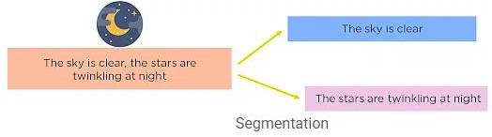
Figure 12.1 Segmentation of document

Tokenizing:
For the algorithm to understand these sentences, need to get the words in a sentence and explain them individually to the algorithm. So, break down the sentence into its constituent words and store them. This is called tokenizing, and each world is called a token.

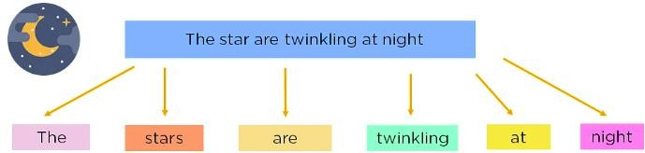
Figure 12.2 Tokenization of segments

Removing of stop-words:
To make the learning process faster by getting rid of non-essential words, which add little meaning to the statement and are just there to make statement sound more cohesive. Words such as was, in, is, and, the, are called stop words and can be removed.
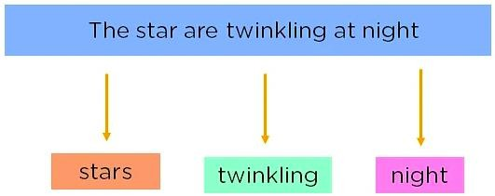
Figure 12.3 Removal of stop words

Stemming:
It is the process of obtaining the Word Stem of a word. Word Stem gives new words upon adding affixes to them.
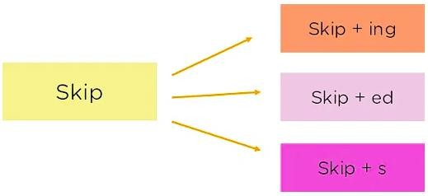
Figure 12.4 Stemming of words

Lemmatization:
The process of obtaining the Root Stem of a word. Root Stem gives the new base form of a word that is present in the dictionary and from which the word is derived. You can also identify the base words for different words based on the tense, mood, gender, etc.

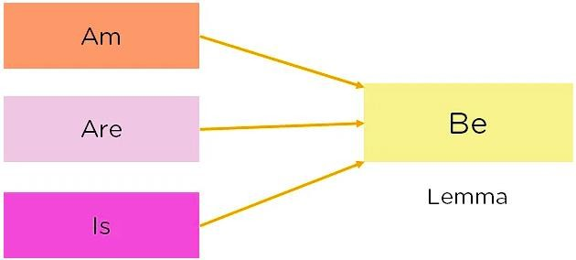
Figure 12.5 Lemmatization

Parts of Speech Tagging:
To explain the concept of nouns, verbs, articles, and other parts of speech to the machine by adding these tags to the words.
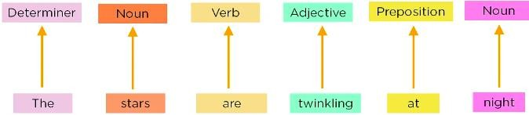
Figure 12.6 Parts of speech Tagging

Named Entity Tagging
Next, introduce your machine to pop culture references and everyday names by flagging names of movies, important personalities or locations, etc that may occur in the document. You do this by classifying the words into subcategories. This helps you find any keywords in a sentence. The subcategories are person, location, monetary value, quantity, organization, movie.

Activity- 1:
Write a python program to remove stop words from any passage using NLTK.

Activity- 2:
Write a python program to POS (Parts of Speech) tagging for any sentence using NLTK.

Activity- 3:
Write a python program to implement Lemmatization using NLTK.

Activity- 4:
Write a python program for Named Entity Recognition for any sentence using NLTK.

